**Project Name : TECH WAVE**

**Short Description: TECH WAVE** is a technology blog site which is a leading source of breaking mobile tech news, and it is intended for tech novices and experts alike. Here we cover the latest technology news and expert tech product reviews. People can learn about the latest gadgets and consumer tech products for entertainment, gaming etc.

**Frontend:** We used Figma to complete our frontend. We try to give a user-friendly and easy to use website.

**Backend :** Work of API’s is given bellow:

**GET**= The **GET** method is used to retrieve data from the server.

**POST**= The **POST** method sends data to the server and creates a new resource.

**PUT** = The **PUT** method is most often used to update an existing resource.

Our backend API design:

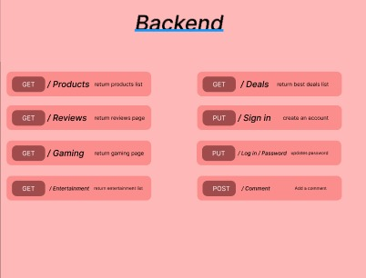

i) **/products:** If user clicks on the products option then it will return the product list. As users is watching the products list so, it’s a GET request.

ii) **/reviews:** If user clicks on the reviews option then it will return the reviews page. It’s a GET request.

iii) **/gaming :** If user clicks on the gaming option then it will return the gaming page. It’s a **GET** request.

iv) **/deals:** If user clicks on the deals option then it will return the deals list. As users is watching the basic deals list so, it’s a **GET** request.

v) **/sign in:** As the user is requesting to create an account, So it’s a **PUT** request.

vi) **/log in/password:** As the user is requesting for update his password, So it’s a **PUT** request.

vii) **/comment :** As the user is giving a comment, So it’s a **POST** request.

**Database:**

**Table 1:** The table is for the Home page. Here products, login and sign up is the primary key.

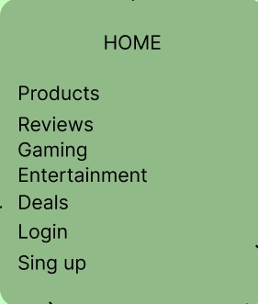

**Table 2:** Here we store our products list. User can choose any option here.

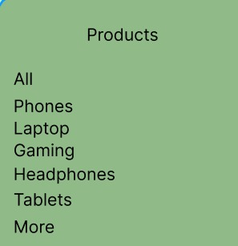

**Table 3:** Here we store reviews of latest products. All are foreign key here.

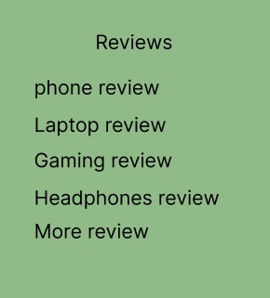

**Table 4:** In this table we store our users information. Here Email address is the primary key.

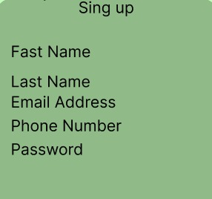

**Table 5:** Here we store the latest news about game and gaming accessories. User can choose any option here.

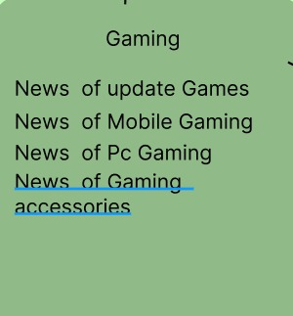

**Table 6:** Here we store some entertainment news. All are foreign key here.

